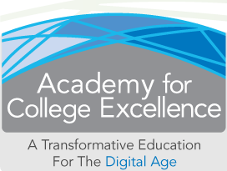
Benefits of ACE:  - Finish all of your English and Math pre-college requirements in 1 semester  - Save money! The only books you need are for your English 90 class  - World-class support  - Curriculum usually reserved for the wealthiest and most privileged  - Wonderful teachers!!  - Skills that will help you with your personal life, academics and your professional career | ACE accelerates full-time English 90 students through all of their English and Math pre-requisites
Interactive Learning  If your idea of college is suffering through long, boring lectures, think again. ACE instructors are going to be constantly engaging you, and asking you what you think. Many exercises are hands-on and get you interacting with your classmates. ACE is fun!  A better chance at success with ACE  Studies have shown that ACE students have a much higher chance of finishing community college and transferring. Spending one semester in ACE is an investment in your success. | Integrated Classes  ACE classes are integrated, which means that behind the scenes your ACE instructors are meeting together and coordinating assignments. This means you’ll never have major assignments due at the same time, which will make being a successful full-time student much more possible. Your ACE instructors work together to maximize your probability of success.  INTERESTED?  Contact Tue Rust  trust@losmedanos.edu  (925) 439-2181 Ext 3474 | www.losmedanos.edu/ACE  2700 East Leland Road, Pittsburg CA 94531

